NP-complete:

1, decision problem (0-1):

2, given a directed graph G, vertices u and , and an integer k, does a path exist from u to consisting of at most k edges?

Reduction:

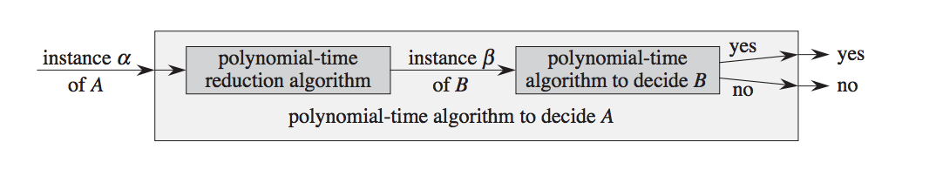

reduction tree:  
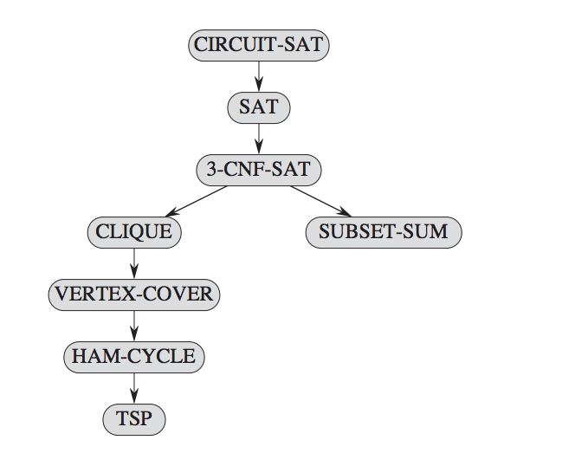

circuit-sat:

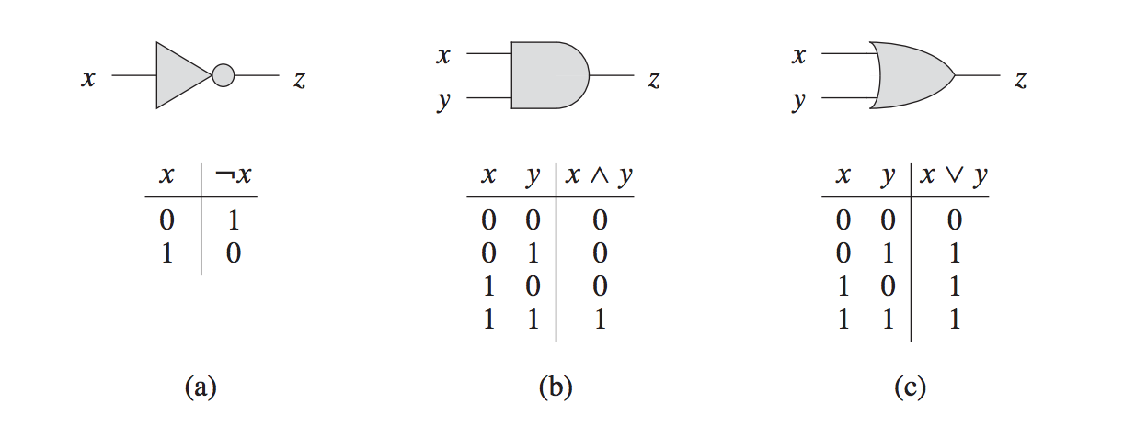

TSP: formal language:

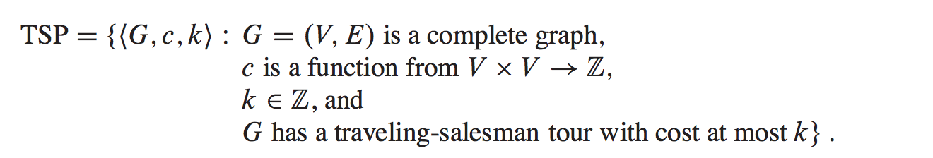

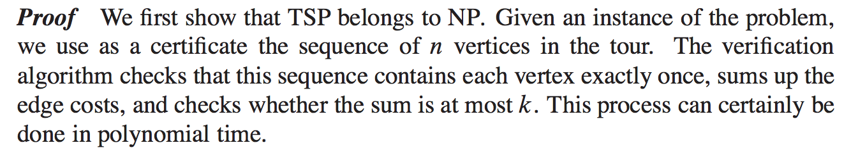

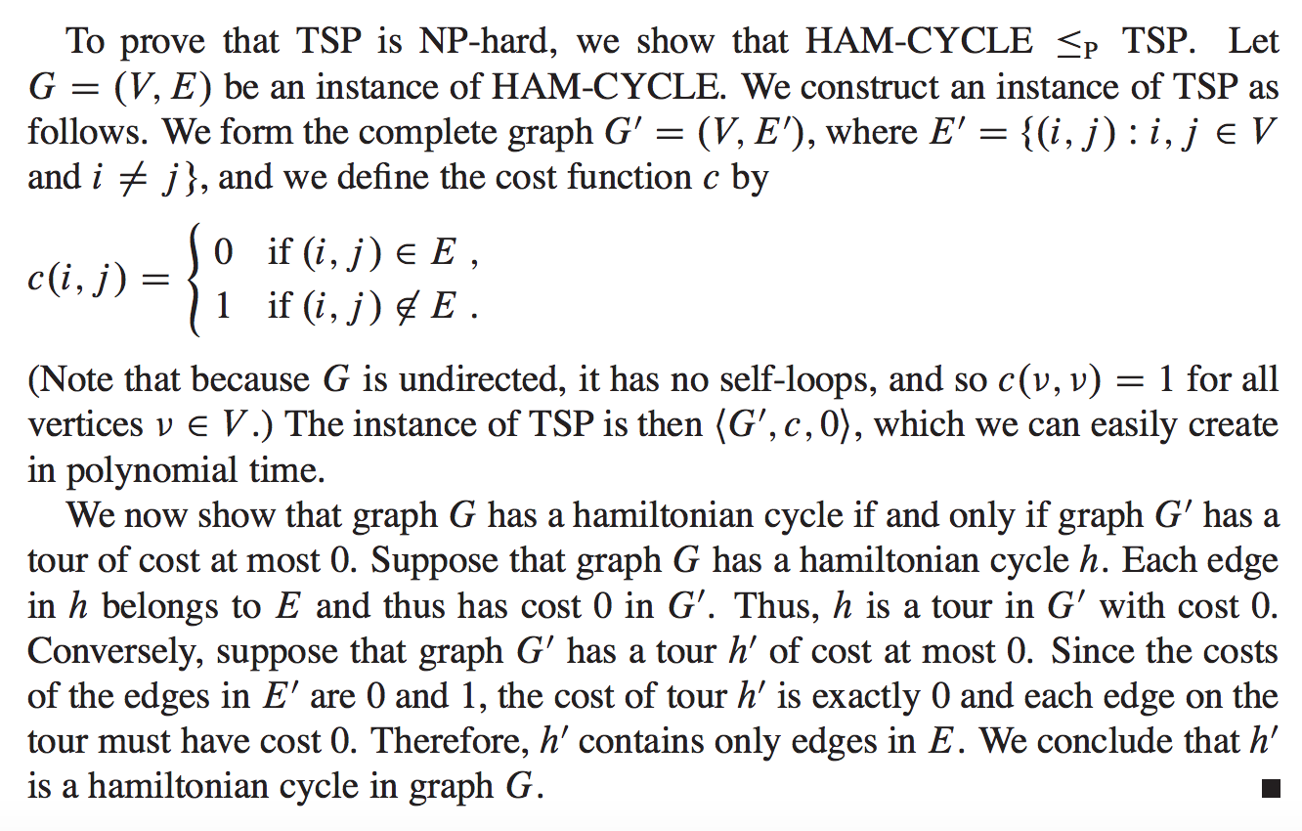

* 1. knapsack problem is a polynomial-time?

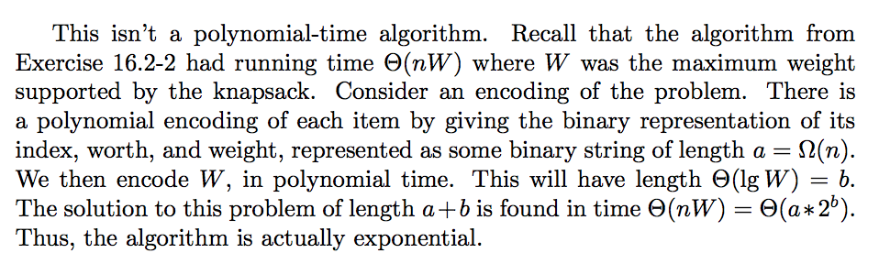

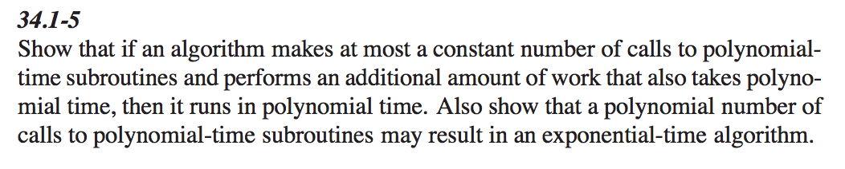

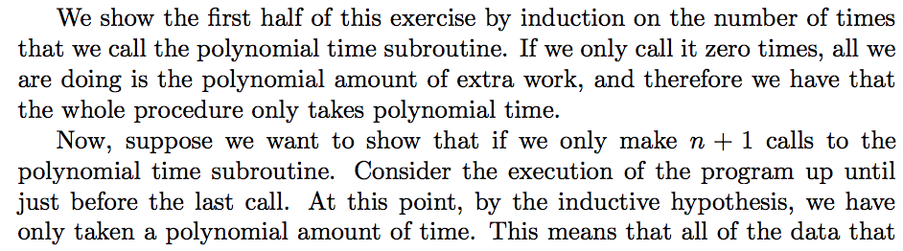

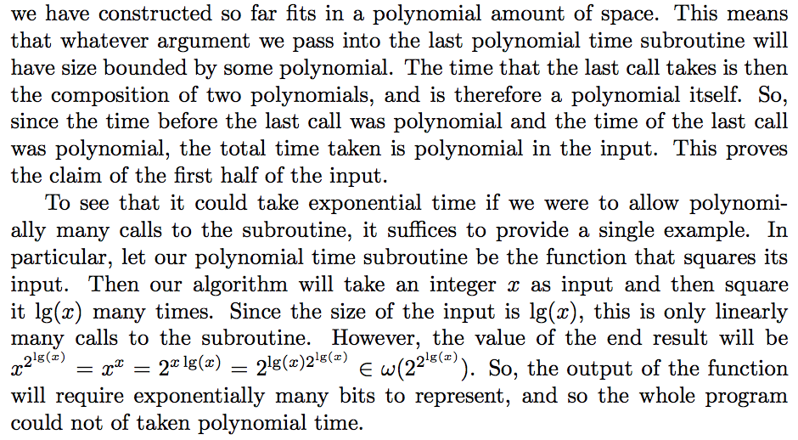

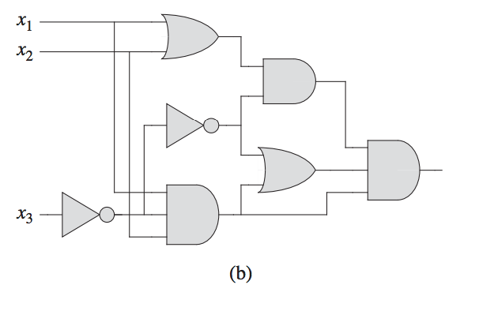

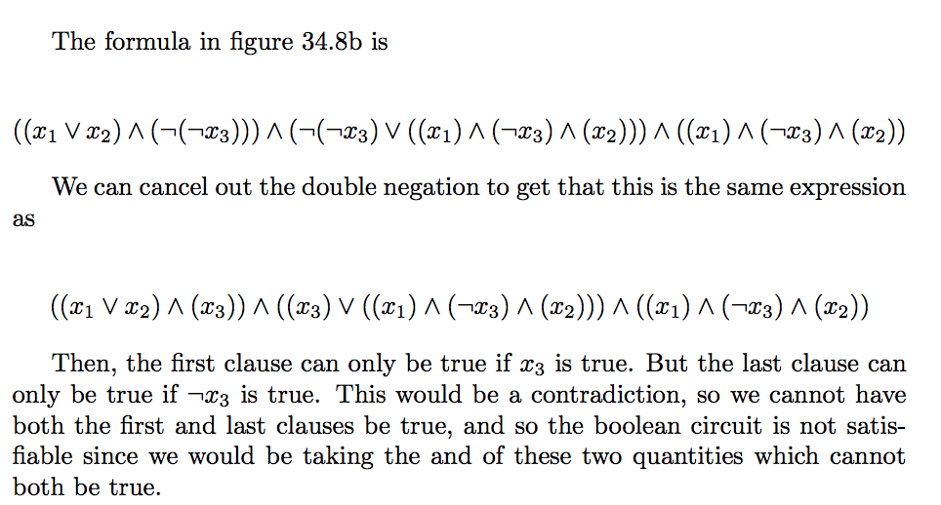

using reduction to prove L is NP-C:

